Power Spectral Density - the basics

Power Spectral Densfty (PSD) is the frequency response of a random or periodic signal. It tells us where the average power is distributed as a function of frequency.

• The PSD is deterministic, and for certain types of random signals is independent of time¹. This is useful because the Fourier transform of a random time signal is itself random, and therefore of little use calculating transfer relationships (i.e., finding the output of a filter when the input is random).

• The PSD of a random time signal x(t) can be expressed in one of two ways that are equivalent to each other

1. The PSD is the average of the Fourier transform magnitude squared, over a large time interval

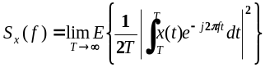

2. The PSD is the Fourier transform of the auto-correlation function.

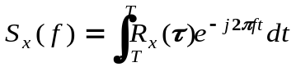

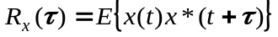

• The power can be calculated from a random signal over a given band of frequencies as follows:

1. Total Power in x(t): 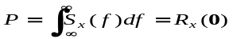

2. Power in x(t) in range f₁ - f₂: 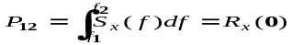

¹The signal has to be stationary, which means that us statistics do not change as a function of time.

• If a random signal x(t) is passed through a time-invariant filter with frequency response H(f), the resulting signal y(t) has a PSD as follows:

x(t)
H(f)
y(t)

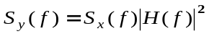

Example: Random Gaussian noise signals.

Two random signals x₁(t) and x₂(t) of 10 seconds duration are created as follows:

» xl=randn(1,10000); % signal 1
» x2=randn(1,10000); % signal 2
» t=linspace(0,10,10000); % time series
» dt = t(2)-t(1); % time increment
» subplot(2,2,1),plot(t,x1) %plot of x1
» subplot(2,2,2),plot(t,x2) %plot of x2

The sample frequency is 1kHz. The FFT of each of these signals is calculated from

» X1=fftshift(fft(x1)); % FFT of signal 1
» X2=fftshift(fft(x2)); % FFT of signal 2
» Df=1/dt; % fequency span
» f=linspace(—Df/2,Df/2,10000); % frequency series
» subplot(2,2,3),plot(f,dB(X1)); %plot of FFT of x1
» subplot(2,2,4),plot(f,dB(X2)); %plot FFT of x2

The plot below shows a 0.1 second snapshot of two random time functions x₁(t) and x₂(t) and the first 10 Hz of the fast Fourier transform of these signals.

This shows that the frequency responses of these random signals are generally different, although they seem to have a common average level, and have similar overall “randomness”, which would be exhibited in the rest of the spectrum if we were to show it.

Perhaps what we should be doing is looking at the average Fourier transform instead of just a single sample of the Fourier transform this is, more or less, what the PSD is; it is the average Fourier transform squared taken over a very long time interval.

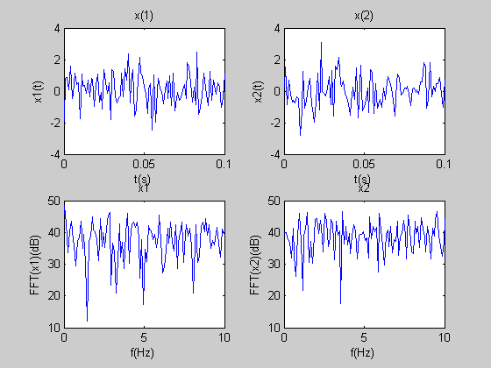

We now calculate and plot the PSD of the original time series x₁(t) and x₂(t).

» x1=randn(1,10000); % signal 1
» x2=randn(1,10000); % signal 2
» t=linspace(0,10,10000); % time series
» dt = t(2)-t(1); % time increment
» Df = 1/dt % fequency span
» subplot(2,2,1),plot(t,x1) %plot of x1
» subplot(2,2,2),plot(t,x2) %plot of x2
» Sx1=psd(x1,1024,1000); %PSD of x1
» Sx2=psd(x2,1024,1000); %PSD of x2
» f=linspace0,Df/2,length(Sx1)); % frequency series
» subplot(2,2,3),plot(f,db(Sx1)); %plot of PSD of x1
» subplot(2,2,4),plot(f,db(Sx2)); %plot of PSD of x2

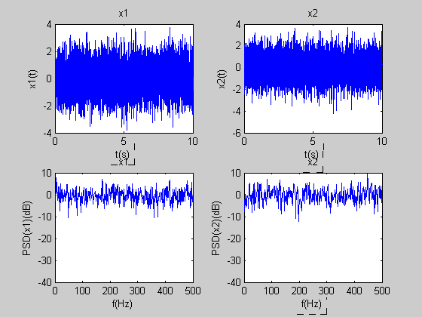

The PSD for each signal looks more or less flat across the frequency band. This type of noise is referred to as white, and if we had taken an infinitesimally small time increment, we would see this flatness across the entire frequency band.

The reason that there is some variation about the constant level is that we didn’t take a large enough (i.e., infinite) time sequence of random numbers to calculate the PSD from. The estimate of the PSD (as calculated in MATLAB) becomes more accurate as the sample size becomes infinite.

The mean of the PSDs of xl and x2 turn out to be very close to 1.

» mean(Sxl) %= 1.0137
» mean(Sx2) %= 1.0241

This is telling us that the average value of the MATLAB PSD, which is the variance, is close to unity.

Now let’s consider filtering the Gaussian noise. First design a high order Butterworth filter that cuts off at half the Nyquist frequency (500 Hz)

»[b,a]=butter(40,0.5); %n=40th order,fc=0.5 nyquist

Now plot the frequency response, normalized to the nyquist frequency (this just makes the maximum frequency be 1)

» freqz(b,a) % plot the frequency and phase response

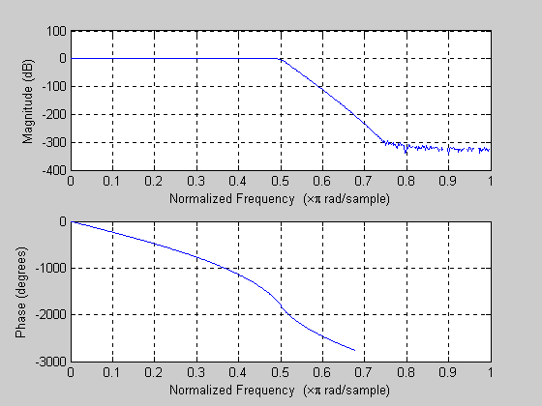

Now produce new noise samples y₁(t) and y₂(t) by filtering x₁(t) and x₂(t).

» y1=filter(b,a,x1); %filter x1
» y2=filter(b,a,x2); %filter x2
» Y1=fftshift(fft(y1)); %calculate frequency response of y1
» Y2=fftshift(fft(y2)); %calculate frequency response of y2
» subplot(2,2,1),plot(t,x1) %plot of y1
» subplot(2,2,2),plot(t,x2) %plot of y2
» subplot(2,2,3),plot(f,dB(X1)); %plot of FFT of y1
» subplot(2,2,4),plot(f,dB(X2)); %plot FFT of y2

We see that the time series is smoother (it has been filtered), but the FFT remains random. The variance of the filtered noise is reduced to roughly 0.5.

» var(y1) %= 0.4895
» var(y2) %= 0.4956

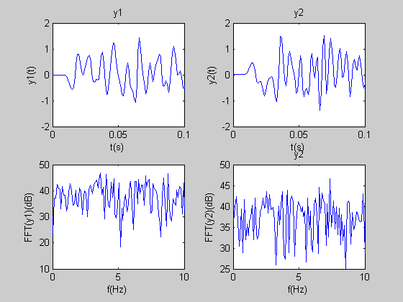

Taking the PSD of the filtered noise

» Sy1=psd(y1,1024,1000); %PSD of y1
» Sy2=psd(y2,1024,1000); %PSD of y2
» f=linspace(0,Df/2,length(Sx1)); % frequency series
» subplot(2,2,1),plot(t,x1) %plot of y1
» subplot(2,2,2),plot(t,x2) %plot of y2
» subplot(2,2,3),plot(f,db(Sy1)); %plot of PSD of x1
» subplot(2,2,4),plot(f,db(Sy2)); %plot of PSD of x2

Basically what we have done here is filtered white noise. The PSD of the filtered noise takes on the shape of the filter frequency response, and is the same (within experimental variation) for each independent noise signal.

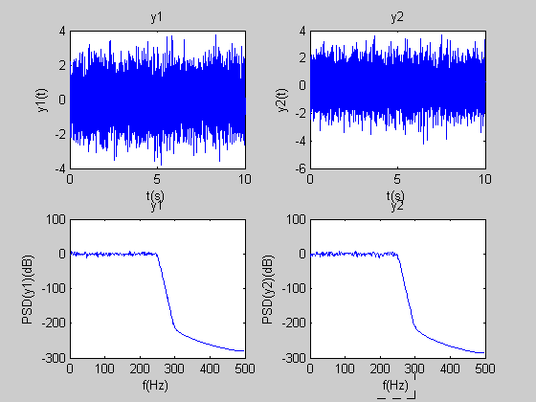

Calculating the variance of the filtered noise results in

»mean(Syl) %= 0.4851
»mean(Sy2) %= 0.4910

The means are both close to 0.5. Not surprisingly, cutting out half the noise with a steep high order Butterworth filter has reduced the total variance by approximately 0.5. The variance for a flat PSD with amplitude S_{x} (W/Hz) and total positive and negative frequency extent Δf is found by (σ_{x})² = S_{x} Δf.

In MATLABs calculation of PSD, Δf is normalized to 1, so (σ_{x})² = S_{y} = 1. For the filtered signal, S_{x} is 1 for half of Δf and 0 for the other half of Δf, so (σ_{x})² = S_{y}/2= 1/2. In general, when the PSD is not simple shaped as in the above examples, you will need to integrate the PSD in order to find the variance. In MATLAB, this is equivalent to simply finding the mean of the PSD.

What can you conclude about the PSD and white Gaussian Noise?

